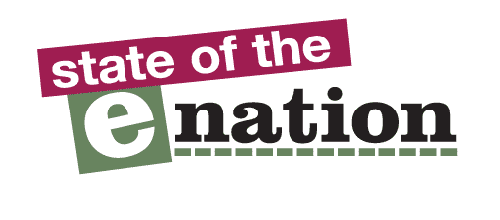

  - State of the eNation accessibility reports

Supermarket Websites
and Apps
  - December 2013

Little Christmas cheer for the disabled
Our review found that most supermarket websites and apps are difficult and frustrating for disabled people to use, which means that many will struggle to complete their grocery shopping online and have their Christmas goodies delivered.

Prepared by: Robin Christopherson, Head of Digital Inclusion and the AbilityNet Accessibility Team

Phone: 01926 312847
Email: accessibility@abilitynet.org.uk
Web: www.abilitynet.org.uk

AbilityNet is a registered Charity in England. No. 1067673 and in Scotland No. SC039866

Contents

1. Summary: Little Christmas Cheer for the Disabled 2

2. The results 3

3. Selected customer comments 4

4. The importance of website and app accessibility 6

5. How we carry out the Accessibility Reviews 7

6. Headline findings of website and app reviews 8
1.1 Tesco Website 8
1.2 Tesco App 9
1.3 Sainsbury's Website 10
1.4 Sainsbury’s App 11
1.5 Asda website 12
1.6 Asda App 13
1.7 Morrisons website 14
1.8 Morrisons App 15
1.9 Ocado website 16
1.10 Ocado App 17
Appendix A - Further Sources of Advice and Support 18

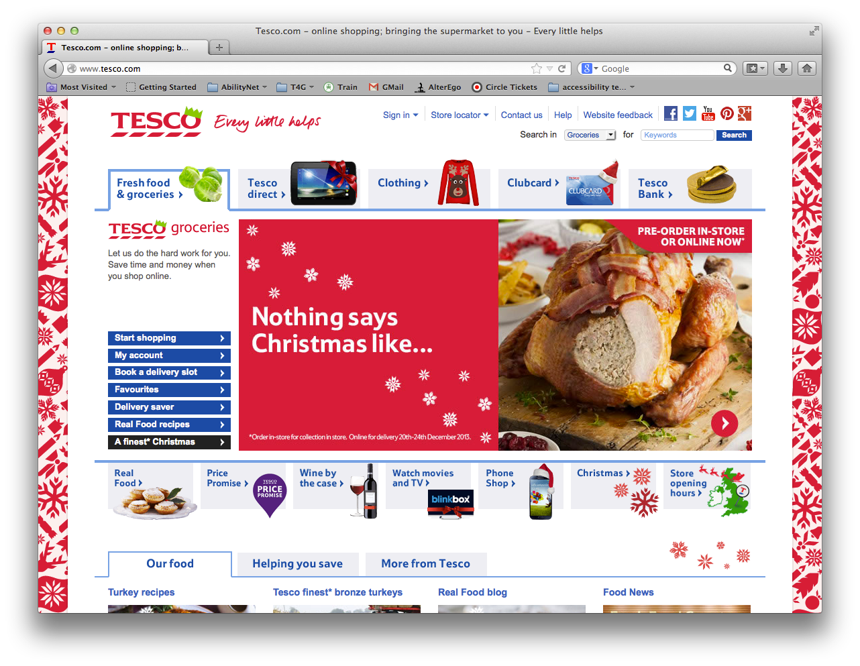
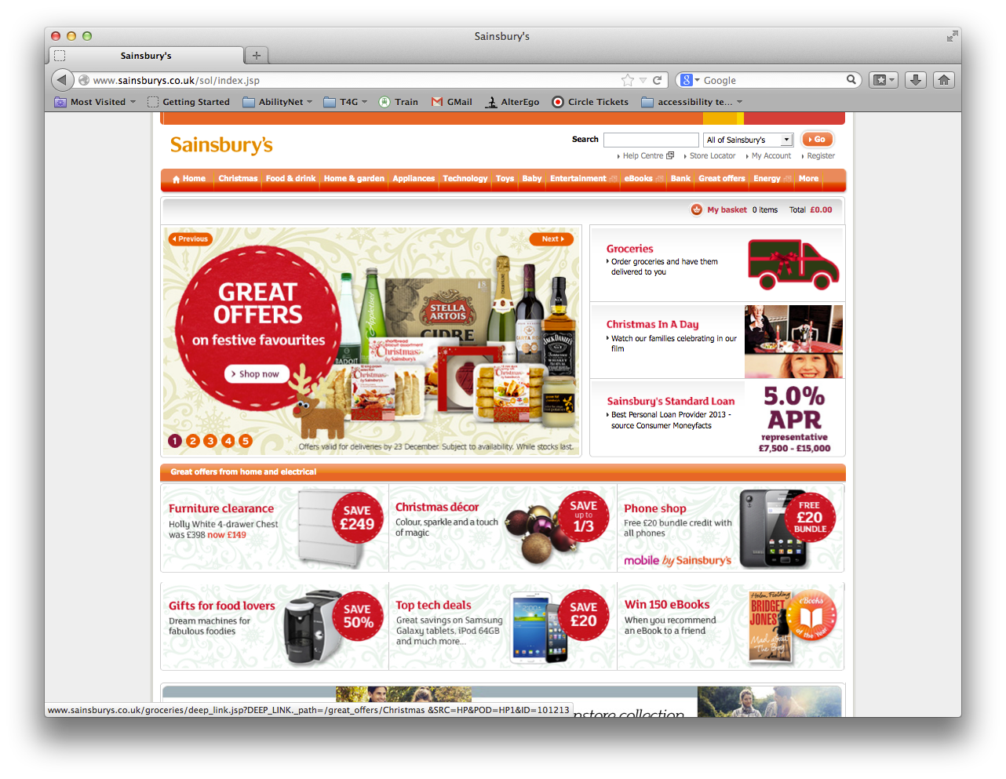
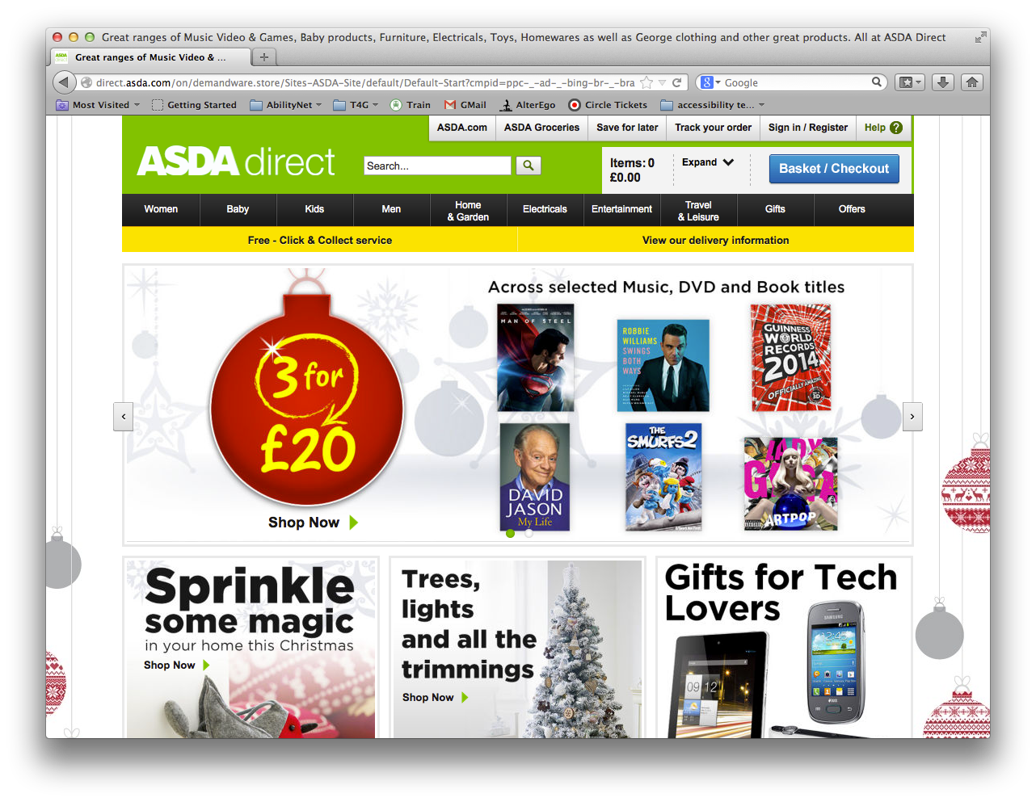
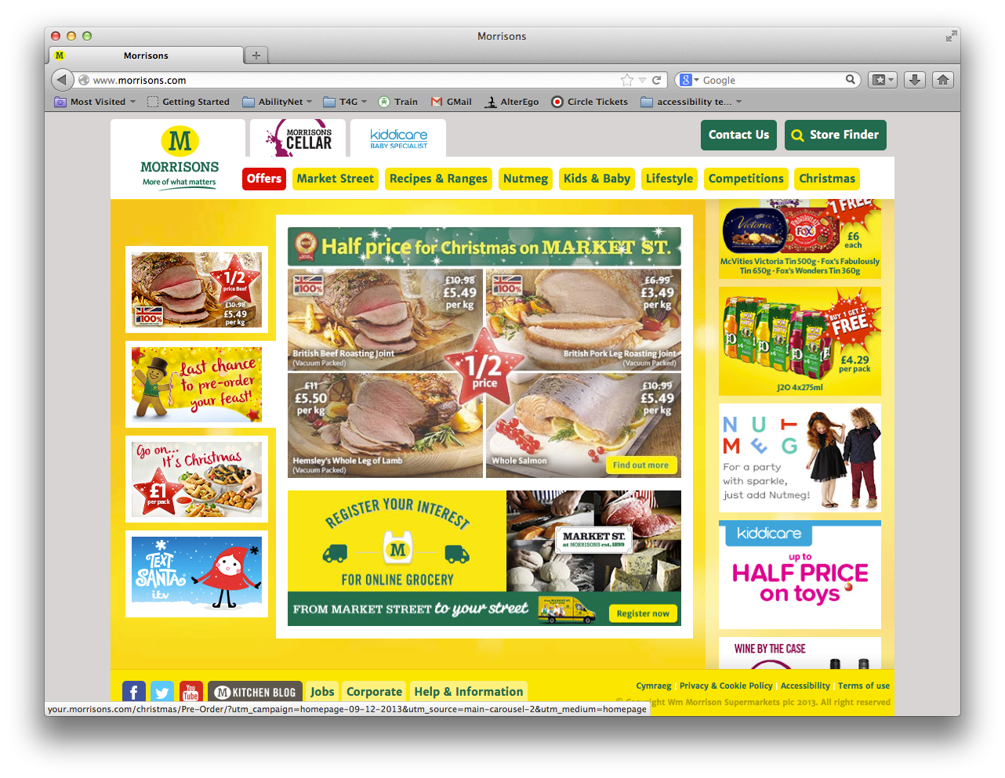
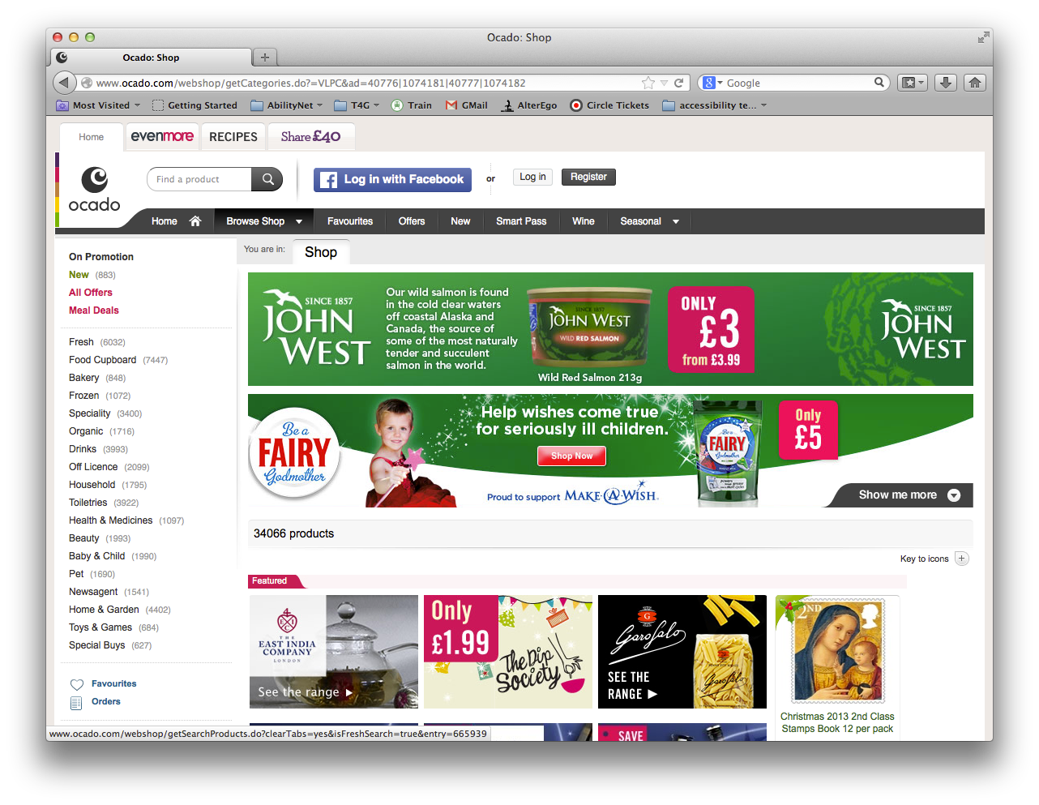
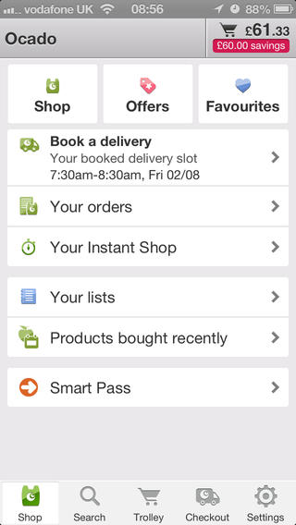
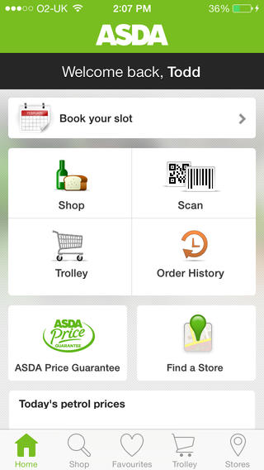
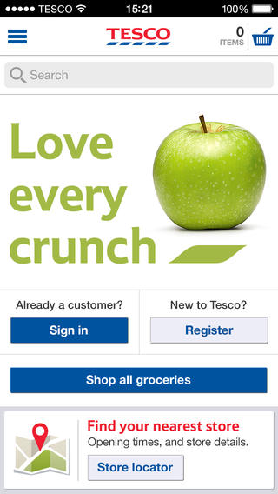
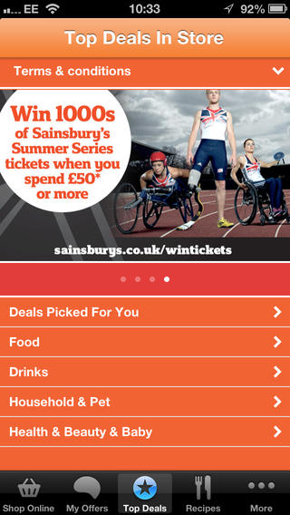

- Summary: Little Christmas Cheer for the Disabled
AbilityNet’s team of accessibility experts audit websites and mobile apps for many companies every month. Our State of the eNation Reports are accessibility and usability reviews of a number of websites and mobile apps in a particular sector.
The run up to Christmas is always a busy time for shopping online, and ordering the turkey and Christmas pud for the big day will be no exception.
Being able to shop online and have goods delivered to your door is a huge convenience for everyone at this busy time of year, but is especially important for people with disabilities who often have difficulty getting to or around shops or handling heavy goods.
Our review found that most supermarket websites and apps are difficult and frustrating for disabled people to use – which means that many will struggle to complete their grocery shopping online and have their Christmas goodies delivered.

- The results
The apps and websites of the following supermarkets were reviewed:
Tesco
www.tesco.com 3 stars Satisfies minimum requirements
Mobile app 3.5 stars Slightly exceeds minimum requirements
Sainsbury’s
www.sainsburys.co.uk 2.5 stars Satisfies some minimum requirements
Mobile app 2 stars Below minimum requirements
Asda
www.asda.com 2.5 stars Satisfies some minimum requirements
Mobile app 2 stars Below minimum requirements
Morrisons
www.morrisons.co.uk 2 stars Below minimum requirements
Mobile app None available
Ocado
www.ocado.com 2.5 stars Satisfies some minimum requirements
Mobile app 4 stars Exceeds minimum requirements

Rating scale
5 stars Excellent. Site/app is highly accessible and exceeds minimum requirements for accessibility and usability
3 stars Base level. Site/app satisfies minimum requirements for accessibility and usability
1 star Very poor. Site/app is not accessible and does not meet minimum requirements for accessibility and usability

- Selected customer comments
Tesco website
"I couldn't see the 'Skip to content' link on the Tesco site and for the tabbing you have to have good eyesight to spot, some are just a slight colour change but at least it is some indication which is more than most!"
Blind screen reader user
Tesco App
"I had trouble finding them. I didn’t realise that the crackers would be under the category 'Groceries' but overall very fast and efficient and precise."
Magnification user
Sainsbury’s website
“This site was difficult to use with misleading buttons such as 'Disabled save trolley', 'Disabled empty trolley' all of which are in fact active. There were also some unlabelled images such as 'icons/grid_British-Flag_v1_m56577569834232415'. Despite these difficulties I was able to complete the tasks with some effort.”
Blind screen reader user
Sainsbury’s app
“I found this app completely unusable as the mobile version of the site it accesses is full of incomprehensible links such as 'Deeplink.js' and you are unable to do anything.”
Blind screen reader user
Asda website
"Did not complete checkout process as found too time-consuming and frustrating. Also there is no accessibility page."
Blind screen reader user
Asda App
“Really confusing. I wasn't able to view the contents of my trolley and couldn't choose a timeslot for delivery (all grid cell items appear blank) and I gave up. Aaaagh!”
Blind screen reader user
Morrisons website
"What a very inaccessible site - I couldn't find anything I was looking for"
Magnification user
“I found it frustrating not being able to easily search for information on items. Get a search engine."
Dyslexia user
Ocado website
"When I was looking for the Christmas pudding and I clicked onto the heading browse shop that's when the problem occurred that if I moved my mouse off the icon the information would disappear and I would have to start the whole process again. I found this irritating."
Magnification user
"I added my items to the trolley and then had to register and afterwards my trolley was empty and it was a bit annoying that after registering I had to do it all over again."
Dyslexia user

- The importance of website and app accessibility

It’s good for business
In the UK there are 11.2 million people with a disability. There are estimated to be 1.6 million who are registered blind, 1.5 million with cognitive difficulties, a further 3.4 million people who are otherwise IT disabled and 6 million that have dyslexia. The total spending power of these groups is now estimated at £120 billion a year.
Being able to go shopping and bring home heavy groceries can be extremely challenging for disabled people who have either mobility or physical difficulties to overcome. Never more so than at this busy time of year when shops are crowded and pavements may be icy.
Moreover saving money is more important than ever and people with disabilities often have less cash and less opportunity to shop around the physical high street. Being able to identify the best bargains helps them overcome physical barriers and at the same time stay within budget.
Good commercial sense suggests that the significant disabled UK customer base should be a key market for any business, yet our research shows that their needs are not well catered for.

It’s the law
Today many services are either only available on, or offered at a discounted rate on, the Internet. Other websites or apps provide vital information or functionality. If a website or mobile app doesn’t meet a base level of accessibility then it will be impossible for a large number of disabled visitors to use. Many others with some sort of limiting condition will also have great difficulty.
It is illegal to bar disabled visitors from on-line services and information offered to the general public. No organisation would purposefully do this but many are either not aware of the problem, or don’t know what to do to address it.

- How we carry out the Accessibility Reviews
The websites and apps were reviewed during a period spanning October and November 2013 for headline accessibility and usability issues. The website or app receives a score based on two types of testing.

Technical Compliance
In the case of the websites our consultants conduct technical checks made by HI Software’s enterprise accessibility testing tool ‘Compliance Sheriff’.
Compliance Sheriff scans a Web site for over 172 accessibility checks including images, forms, and dynamic content. The results are then available in a report which includes the exact locations of code issues, as well as alerts to elements that require manual inspection.
This test produces a series of charts which is summarised in an overall health rating, which is included in each site report.
Note that each site’s health rating is based not only on the number of passes, fails and visual checks (issues that need further inspection) but also on the severity of the fails and the potential severity of those issues still requiring clarification.
A health rating of 40% or more indicates that a site is usable but may well still present significant issues for a user.

Disabled user testing
For the websites and apps a range of disabled users endeavoured to add items to their shopping basket (a turkey, Christmas pudding and a dozen crackers).
The disabled user testing ensures that we are able to ascertain the ‘real life’ accessibility and usability of each website and app. These provide a view from the coalface and pertinent quotes are included within this report to provide an insight into their experiences.
The websites were tested on IE10 and 11 and the apps were those provided for Apple’s iOS (found on iPhone’s, iPads and iPod Touches).
iOS is well placed to provide an accessible platform and the ‘building blocks’ (software development kit or ‘SDK’) makes for the easy creation of accessible apps and is therefore often the favoured platform for disabled users.

- Headline findings of website and app reviews

Tesco Website

Overall score
www.tesco.com: 3 stars Satisfies minimum requirements

Technical compliance
Health Score: 47%
Failed: 8.7%
Warning: 1.2%
Visual Check: 30.4%
Passed: 59.7%
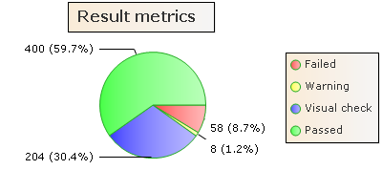
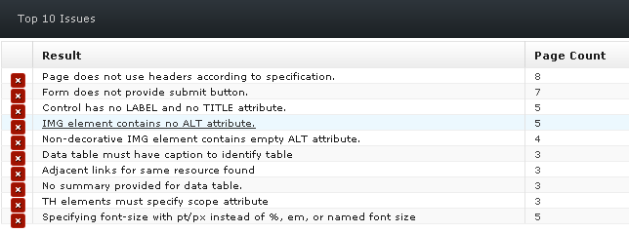

Disabled User Comments
Screen Reader user
“It was relatively straightforward to complete all the transactions despite some poorly labelled images.”
Magnification user
“No real problems but I found it time-consuming using magnification software and the site kept crashing for some reason.”
Dyslexia user
“I had no difficulties to speak of but it took quite some time to register.”
Keyboard user
"I couldn't see the 'Skip to content' link on the Tesco site and for the tabbing you have to have good eyesight to spot, some are just a slight colour change but at least it is some indication which is more than most!"

Tesco App

Overall score
Mobile app: 3.5 stars Slightly exceeds minimum requirements

Technical compliance
No technical audit available for mobile apps

User comments
Screen reader user
“Despite some unlabelled buttons I found it relatively easy to use and was able to complete all the tasks ok.”
Magnification user
"I had trouble finding them. I didn’t realise that the crackers would be under the category 'Groceries' but overall very fast and efficient and precise."

Sainsbury's Website

Overall score
www.sainsburys.co.uk: 2.5 stars - Satisfies some minimum requirements

Technical compliance
Health Score: 46%
Failed: 6%
Warning: 0%
Visual Check: 21.5%
Passed: 72.5%
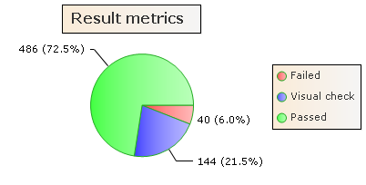
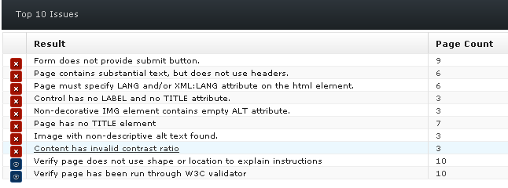

Disabled user comments
Screen reader user
“This site was difficult to use with misleading buttons such as 'Disabled save trolley', 'Disabled empty trolley' all of which are in fact active. There were also some unlabelled images such as 'icons/grid_British-Flag_v1_m56577569834232415'. Despite these difficulties I was able to complete the tasks with some effort.”
Magnification user
"This site was easy for me to access because the layout is the same throughout. However, while using my ZoomText magnification software the headings on the website became distorted making it very difficult for me to read. This is because the site often uses pictures of text instead of actual text which becomes distorted when it is magnified unlike actual text.”
Dyslexia user
“Found all the tasks relatively easy and no problems.”

Sainsbury’s App

Overall score
Mobile app: 2 stars Below minimum requirements

Technical compliance
No technical audit available for mobile apps

User comments
Screen Reader user
“I found this app completely unusable as the mobile version of the site it accesses is full of incomprehensible links such as 'Deeplink.js' and you are unable to do anything.”
Magnification user
“This app was relatively easy to use but the text was quite difficult to see even with the use of magnification. Even with a combination of magnification on the screen (‘Zoom’) and my handheld magnifier the font was too small.”

Asda website

Overall score
www.asda.com: 2.5 stars - Satisfies some minimum requirements

Technical compliance
Health Score: 39%
Failed: 11.8%
Warning: 1.2%
Visual Check: 30.6%
Passed: 56.4%

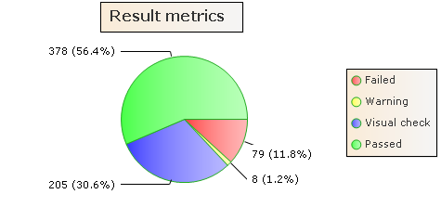

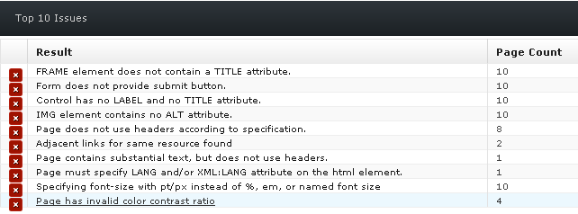

Disabled user comments
Screen reader user
“I found it very difficult to use. Many focus issues with alert boxes ('Are you sure you want to empty your trolley?') not gaining focus and often search results not appearing to be present on the page. Sometimes the 'Add' link doesn't appear to be a link and I had great difficulty adding things to my trolley. Did not complete checkout process as found too time-consuming and frustrating. Also there is no accessibility page.”
Magnification user
"It would be useful when clicking on an icon that they give a response so I am aware something is happening. When I clicked on 'Christmas pudding' I didn’t notice that the information appeared below which left me waiting and not sure what to do next. Eventually I moved my mouse around and I saw pictures of Christmas puddings and figured out what had happened."
Dyslexia user
"I felt like I was bidding on eBay to get a delivery slot, if it's slow now, how is it going to be in the build up to Christmas. It's going to crash."
Keyboard user
“They have a ‘Skip to content’ link but when I used it I then couldn’t easily see where the highlighted link was in the body of the page.”

Asda App

Overall score
Mobile app: 2 stars - below minimum requirements

Technical compliance
No technical audit available for mobile apps

User comments
Screen reader user
“Real difficulties with unlabelled buttons and adding things to my trolley as often the Add button didn't seem to work. On the Trolley tab you get two items 'Delivery cell' and 'Empty trolley cell' even though you have items in your trolley. Really confusing. I wasn't able to view the contents of my trolley and couldn't choose a timeslot for delivery (all grid cell items appear blank) and I gave up. Aaaagh!”
Magnification user
“I had no real problems doing the tasks”

Morrisons website

Overall score
www.morrisons.co.uk: 2 stars - below minimum requirements

Technical compliance
Health Score: 39%
Failed: 12.8%
Warning: 0.1%
Visual Check: 31.8%
Passed: 55.7%

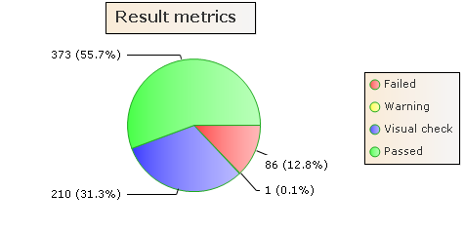

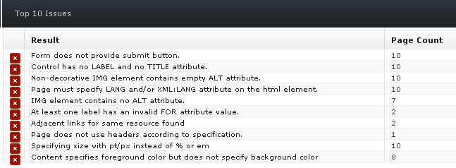

Disabled user comments
Screen reader user
“Some poorly labelled buttons but more to the point it does not offer online shopping as far as I could tell so no real use to me.”
Magnification user
"What a very inaccessible site - I couldn't find anything I was looking for"
Dyslexia user
“I found it frustrating not being able to easily search for information on items. Get a search engine."

Morrisons App

Overall score
App not applicable - no mobile app available

Ocado website

Overall score
www.ocado.com: 2.5 stars - Satisfies some minimum requirements

Technical compliance
Health Score: 40%
Failed: 11.6%
Warning: 0.1%
Visual Check: 33%
Passed: 55.2%

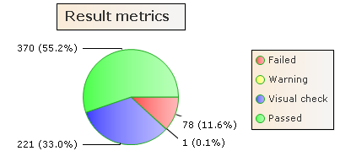
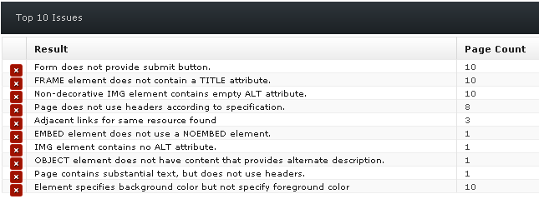

Disabled User comments
Screen reader user
“This site was not easy to use. Poorly labelled buttons such as 'Submit query' to add to basket and others just labelled 'Button'. Under each search result heading you get four repeated links that are really uninformative (such as searching for 'Christmas pudding' gives four identical links underneath of 'Christmas shop'). I was also not able to go to the checkout as 'Checkout' did not appear to be a clickable link and it didn’t work. Boxes such as 'Empty this trolley?' do not gain focus when they pop up so the user wouldn’t know they are there.”
Magnification user
"When I was looking for the Christmas pudding and I clicked onto the heading browse shop that's when the problem occurred that if I moved my mouse off the icon the information would disappear and I would have to start the whole process again. I found this irritating."
Dyslexia user
"I added my items to the trolley and then had to register and afterwards my trolley was empty and it was a bit annoying that after registering I had to do it all over again."

Ocado App

Overall score
Mobile app: 4 stars - exceeds minimum requirements

Technical compliance
No technical audit available for mobile apps

User comments
Screen reader user
“Wow - easy and straightforward to use. All fine.”
Magnification user
"When I tried to download the application it kept saying it was downloading the Ocado catalogue but kept crashing at 30%. I tried this four times before giving up."
Appendix A - Further Sources of Advice and Support

AbilityNet
• www.abilitynet.org.uk
AbilityNet helps some of the biggest companies in the UK to make their websites and mobile apps accessible and usable for everyone – including accessibility audits, disabled user testing, training, expert support and accessible web design.
For further details please email accessibility@abilitynet.org.uk

Web Content Accessibility Guidelines
• www.w3.org/TR/WAI-WEBCONTENT
The World Wide Web Consortium (W3C) is the body at the forefront of the development of standards in good design on the World Wide Web (including accessibility). The W3C's Web Content Accessibility Guidelines (WCAG) form the basis of all other standards.

Authoring Tool Accessibility Guidelines 1.0
• www.w3.org/TR/WAI-AUTOOLS/
The W3C publish standards for tools which allow users to publish content. Vendors of content management systems (CMS) and applications which allow the user to create content should adhere to the Authoring Tool Accessibility Guidelines (ATAG).

Accessible Rich Internet Applications Suite (WAI-ARIA)
• www.w3.org/WAI/intro/aria
Many websites and web applications heavily rely on scripting languages such as JavaScript and AJAX to allow complex interactions with the user. The Accessible Rich Applications (ARIA) suite is a series of documents which are working towards making AJAX and related technologies accessible.

Illustrated handbook for web management teams
• www.cabinetoffice.gov.uk/e-government/resources/handbook/introduction.asp
The UK E-government Unit has guidelines on web accessibility (based upon the W3C guidelines). These can be viewed on-line or downloaded as an illustrated Word document.

Equality and Human Rights Commission
http://www.equalityhumanrights.com
Organisations are legally obliged to provide websites that are accessible to disabled people. This website includes information on the Equality Act (2010), its accompanying code of practice and their report outlining the findings of research into the accessibility and usability of websites.

