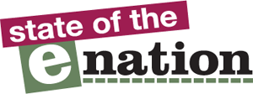

AbilityNet State of the eNation Accessibility Reports
Election 2015:
Political Parties’ Websites Accessibility Report

April 2015
This report looks at how easy it is for disabled people to use the websites of the main political parties contesting in this year’s General Election:
- Our tests found that these sites are difficult and frustrating for disabled people to use and in many cases they could not complete the tasks.
- As well as potentially turning away voters, none of the sites comply with minimum legal standards for accessibility.

Report prepared by Robin Christopherson, Head of Digital Inclusion.
Sites tested by the AbilityNet Accessibility Team, April 2015

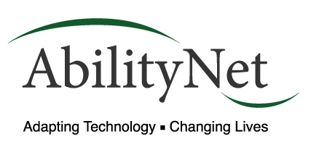
Tel: +44 (0)1926 465 247
Email: sales@abilitynet.org.uk
Web: www.abilitynet.org.uk/enation
About AbilityNet
AbilityNet is a charity and a global leader in helping people with disabilities to use digital technology to improve their lives at work, at home or in education. As well as free support to disabled people we provide specialist professional services to international businesses such as Barclays, E.ON and BT.
- Our team of accessibility experts conduct audits of websites, mobile apps and other digital services.
- Our disabled testers conduct user tests on websites and other digital services using desktop computers, mobiles and tablets.
- Our consultants provide specialist support and training to digital and development teams as well as working with marketing and compliance staff.
As well as fulfilling the business goals of our clients our work helps make the digital world a more accessible place for every disabled person.

About eNation reports
AbilityNet’s State of the eNation Reports are accessibility and usability reviews of a number of websites in a particular sector. A full archive of reports from the past 12 years can be found at www.abilitynet.org.uk/enation

Contents

1 How they ranked 4
2 Why is web accessibility important to political parties? 6
3 What is web accessibility and who does it affect? 7
4 How we test the sites 8
5 Summary of results 10
6 Contact Us 22

How they ranked
This is the closest election for generations, but is also the most digital we have ever seen. AbilityNet conducted industry standard tests on all seven of the main party websites, including checking the code, disabled user testing and manual checks for best practise.

ELECTION 2015: ACCESSIBILITY TEST RESULTS
NONE of the websites tested achieved legal compliance
This list shows how well they performed against each other, but none of them achieved the internationally recognised minimum standard.
1 |  | The Labour Party
2 |  | The Scottish National Party
3 |  | The Liberal Democratic Party
4 | 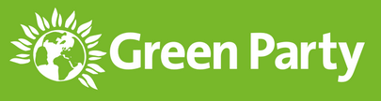 | The Green Party
5 |  | The Conservative Party
6 |  | UK Independence Party
7 | 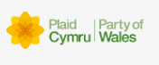 | Plaid Cymru

Aside from the obvious concerns about our main political parties not complying with current legislation, there are many millions of people of voting age who may have impairments and disabilities who would be prevented from effectively using these websites.
Some of the quotes we gathered from our testers show the frustrations in accessing the information about the parties and their policies:
"This website is too busy and not well-signposted. I felt frustrated with it quickly and would have to be have been really determined to stay on it in search of info."
"I think it should be much better sign-posted that it’s possible to ask policy questions."
“I tried to download the manifesto as a PDF but for some reason my anti-virus said it was dangerous and wouldn't allow me to open it. I don't usually have this problem!"
Many more quotes from our testers are included in the results in this report. Although some are very positive many users struggled to complete the tasks that we set and every site failed to achieve the recognised legal requirements.
Many of the issues identified can be resolved quickly and easily, often at no cost, so it is disturbing to consider how many potential voters will be hindered from actively engaging in political issues through these websites.

Why is web accessibility important to political parties?
As well as being a legal requirement the web is a key communications channel for every party. Moreover, achieving accessibility delivers better usability for millions of potential voters and not simply those with a disability.

There are three main reasons why website accessibility is important in this election:

Reaching millions of potential voters
- There are 12 million disabled people of all ages in the UK - and 10 million over 65s who struggle to use new technologies, or face difficulties due to failing eyesight or other impairments.
- This fiercely competitive election is the most digital campaign we’ve ever seen. Badly designed, inaccessible websites affect millions of people, meaning they could be failing to reach significant numbers of voters.
- Although spending large amounts on their websites, many of the issues raised are easily and cheaply fixed. This could offer a simple way to stand out from the other parties.

The ethical, moral and social case - it’s simply the right thing to do
- Every party has a responsibility to their supporters to ensure that they play a positive role in helping everyone participate in both democratic and community activities.
- As our testers experienced, many are failing to mention disabled people in their policies, make enquiring about disability-related policy difficult, and are further excluding them due to the design of their websites.

The legal case – it’s the law!
- The Law is also clear on this issue. Having a badly designed website means you are discriminating against disabled people and could be liable to legal action under the Equality Act.
- In the UK, website owners must make 'reasonable adjustments' to ensure that they are accessible to disabled users - as set out in the Equality Act 2010 and confirmed in the subsequent Statutory Code of Practice.

What is web accessibility and who does it affect?
There are an estimated 12 million people in the UK with a disability, of which only 8% use a wheelchair. An estimated 6 million have dyslexia and many more have impairments which are age-related.

The web is used by people of all ages and many of the services we rely upon are only accessible through a website. We haven’t moved to electronic voting yet but every party is doing all it can to use the web, social media and other channels to reach out to voters and find every way of inching ahead in this incredibly close campaign.
Many people have invisible disabilities, such as Dyslexia, which can affect their everyday lives (and in many cases remain undiagnosed). Many people may try to cover up their disability or not mention it because of embarrassment or fear of discrimination.
People with disabilities are being put at a disadvantage because those who design websites and apps do not consider their needs. Although some may use specially adapted equipment most use mainstream devices such as mobile phones, tablets and PCs.
For example the testers in our network include people with:
- Dyslexia – up to 6m people in the UK have dyslexia - 4m severely so
- Sight loss – 360,000 people are registered as blind or visually impaired, whilst 2 million Britons have some kind of vision impairment or sight loss
- Hearing Loss - 10 million people in the UK are deaf or hard of hearing
- British Sign Language users – there are approximately 50,000 users in the UK
Feedback from testers may relate to their disability or impairment but, as you’ll see from their comments below, they are also regular users of websites and the internet and their feedback is relevant to all users of a specific website, app or digital service.

How we test the sites
Our industry standard tests provide a combination of automated testing, user testing and checks by our experts.

Automated testing
AbilityNet conducts accessibility tests every day. Our experts provided the accessibility testing for the London 2012 Olympics and Paralympics websites, and our current clients include Barclays Bank, BT and many other blue chip companies.
As a first step we use industry standard testing tools to check the code of the websites. This is a quick way to identify issues and check for technical compliance with the widely adopted international standards known as Version 2.0 of the Web Content Accessibility Guidelines (WCAG2.0).

Disabled User testing
Automated tests check code for technical compliance but the best way to establish whether a website is accessible is to ask people with a range of impairments to test it. Our testers illustrate the range of people who could be affected by the design and coding of a website.
We asked our testers to visit each of the seven sites and carry out two tasks:

Users of magnification software.
This software is used by people with a vision impairment, which may be age-related. The software they use could include some 'text to speech' capabilities – reading out what is on screen – because such high levels of magnification can make it very difficult to read large amounts of text. In terms of the website design these users require accessibility at both the presentational and code-level.

People with fine motor difficulties.
There are a range of medical or age-related conditions such as Parkinson’s that make accurate or time-dependant use of a mouse challenging. Equipment can be adapted – the mouse speed can be slowed down for example – but website designers need to consider the size and proximity of clickable (or tappable) items and avoid hovering on pop-up menus.

Screen-reader users
Someone with impaired vision, or someone with an extreme literacy impairment, will often rely upon 'text to speech' software. This reads out what is on screen and requires a high level of accessibility in both the code of a website and in its structure. The site needs to work properly without the usual visual clues to help someone identify information or perform specific tasks.

British Sign Language users
Any multimedia content that includes narration needs to have subtitles, but it is also important that users whose first language is BSL can also easily read a website's contents. This is because BSL has a reduced vocabulary and simplified grammar structure and 'Plain English' is vital to assist their understanding.

Keyboard only users
Many people have physical or vision impairments that mean they are unable to use a mouse to navigate a website. They will rely on the site being completely accessible from the keyboard – using the keys to move around the screen and select options. This can be easily achieved when creating the website but many sites include drop-down navigation and other interactive elements that require the use of a mouse, which makes the site completely unusable.

Consultant checks
Our expert teams conduct tests every day. As well as checking the results of the automated tests, they review feedback from users look for any evidence of best practise, such as clearly labelled accessibility help and information on the site.
When working with clients our team will provide feedback on test results and work closely with web developers and other technical staff to identify solutions that will address the issues raised.

Summary of results
The following provides a brief summary of how we judged the compliance and usability of the sites. We have used a traffic light system to refer to the issues we found:
Red: many issues identified, immediate action required
Amber: some issues identified, attention required
Green: No immediate issues identified

Labour Party
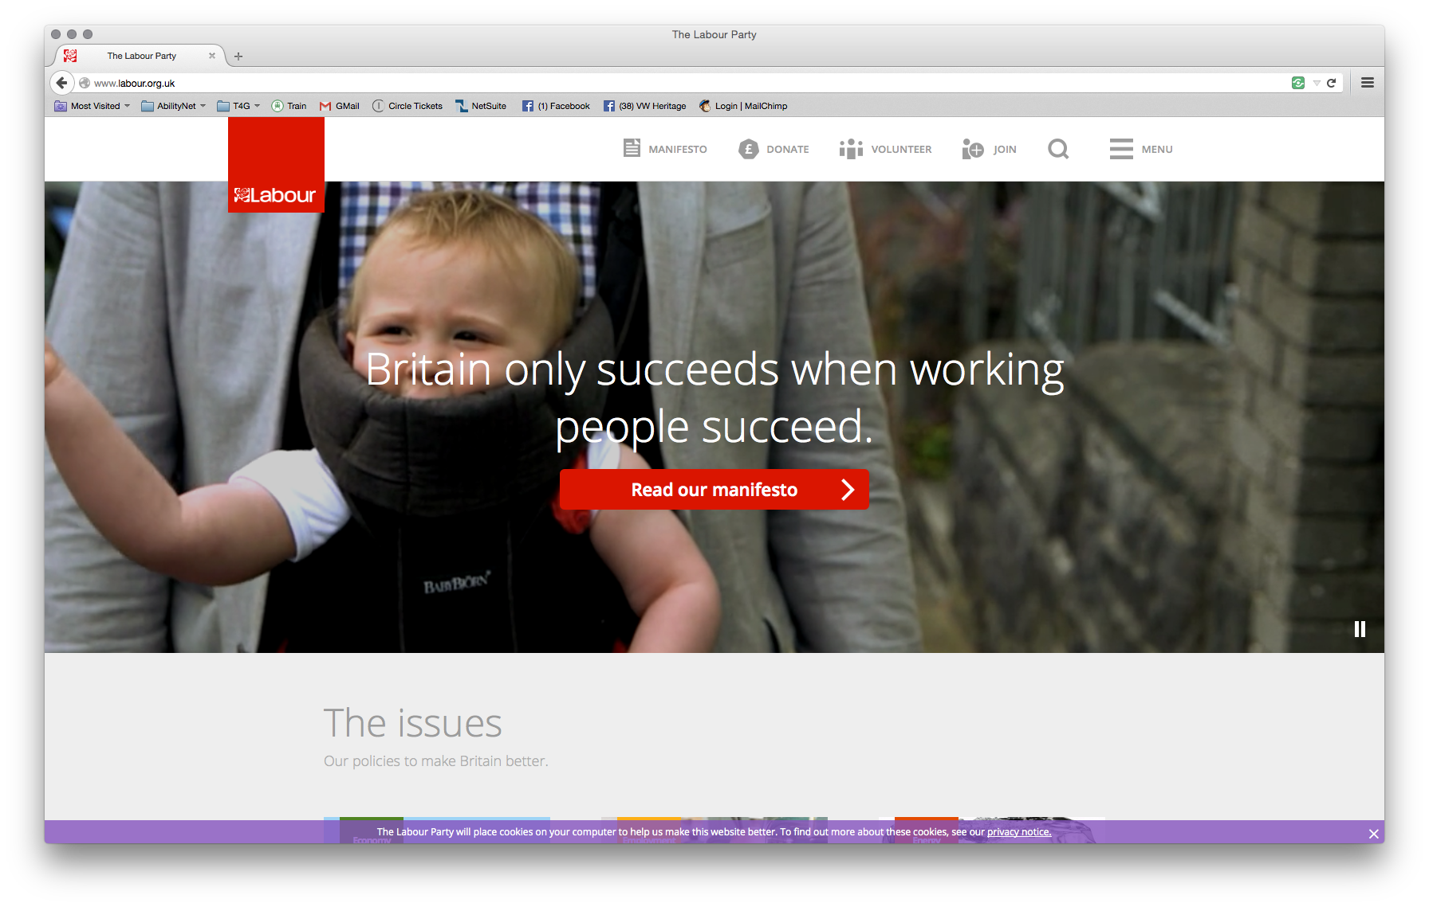

Technical compliance
- Red

User testing
- Amber

Accessibility Best Practise
- Green
- Provides information on accessible alternative formats, gives information on site accessibility and invites feedback on website accessibility)

User testing comments
Screen reader - Green
"Apart from a few unlabelled images the site was easy to use. It was good to see Labour's manifesto summary available in Braille and audio."
Magnification - Amber
"When I entered the website I didn’t know how to access the main website as it kept trying to make me fill out a form. Soon, after at the top right of the screen in a small font a saw something which said ‘continue to main site’."
Dyslexia - Green
"The manifesto contained a mixture of videos and text which is helpful if you have dyslexia and keeps you interested."
Keyboard only - Red
"I was not able to access the drop-down menus from the keyboard. The most basic of requirements to decide whether to vote for a party or not is to understand their policies – I could not even do this, so it’s a vote loser."
Fine motor difficulties - Amber
"I think it should be much better sign-posted that it’s possible to ask policy questions."
BSL - Green
"Easy site to use. I liked that you don't have to give a telephone num ber when submitting an enquiry as being deaf it isn't my preferred method. It would have been nice to have the manifesto available in BSL."

Scottish National Party
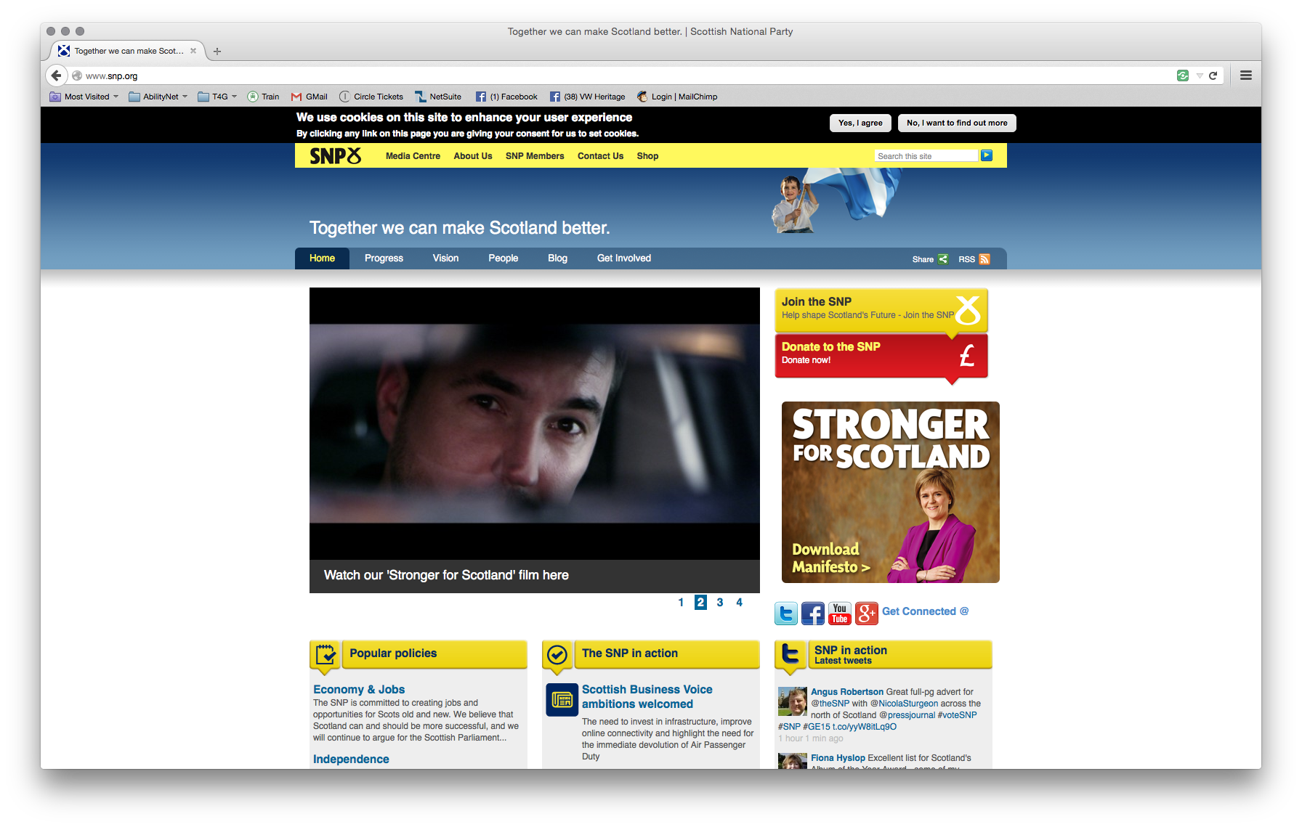

Technical compliance
- Amber

User testing
- Red/Amber

Accessibility help/info
- Amber - Has an Accessibility help page but not very informative

User testing comments
Screen reader - Red
"I eventually found a form I could use to send in an enquiry about their policies regarding the disabled but it used a CAPTCHA image with no audio alternative so I couldn't have submitted it. Ugh."
Magnification - Amber
"The Scottish National Party website is very clear to read. With my magnification software the text is still very clear which is unusual as most websites become distorted at higher levels of magnification making it difficult to read. However when I tried to ask a question it seemed like you have to become a member before you can so I wasn't able to."
Dyslexia - Green
"It was very easy to find the contact us form to submit an enquiry."
Keyboard only - Red
"As a keyboard user there was a lot of tabbing and it wasn’t necessarily logical – far too many links on a page, which felt cluttered."
Fine motor difficulties - Amber
"This website is too busy and not well-signposted. I felt frustrated with it quickly and would have to be have been really determined to stay on it in search of info."
BSL - Amber
"Of all the websites I found this to be the most unclear in terms of navigation and the way that text is laid out (in addition, the text is rather small)."

Liberal Democrats
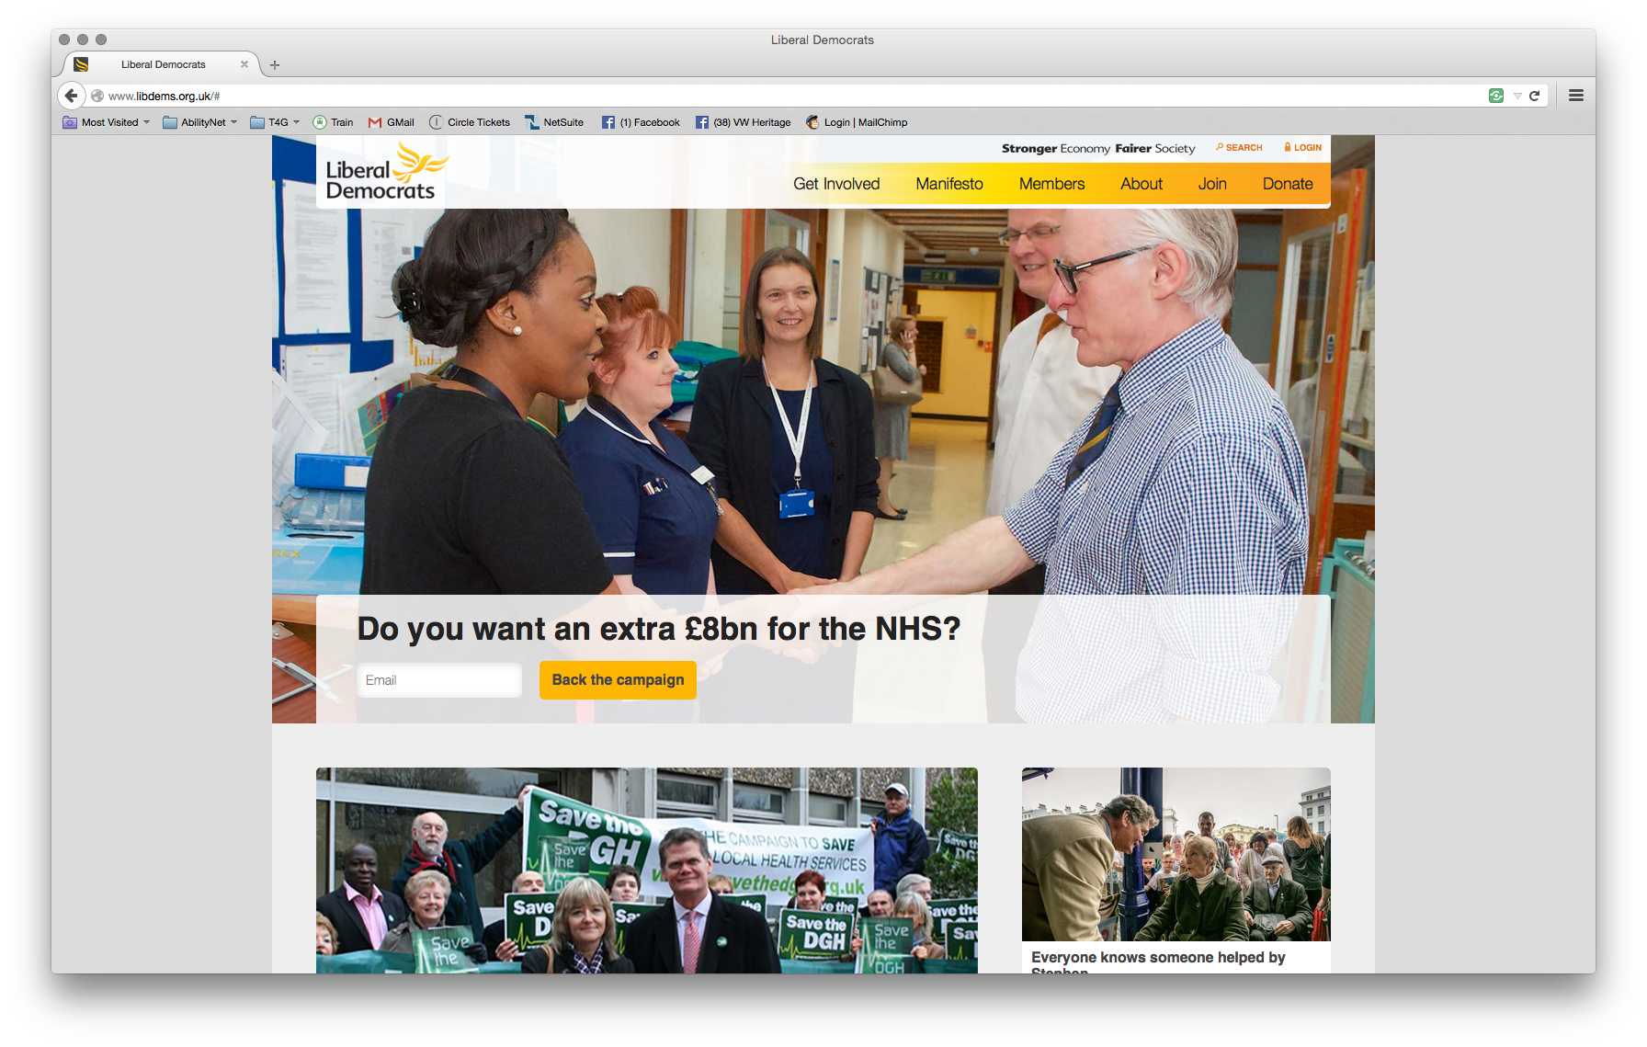

Technical Compliance
- Red

User Testing
- Amber/Green

Accessibility Help/Info
- Amber
- Helpful info on manifesto alternative formats but no obvious disability or accessibility-related site info)

User testing comments
Screen reader - Green
"I found it very easy to find and fill out the form to ask a question about their policies for disabled people. I was interested to learn that the manifesto would be not only in Braille, but large print, audio, easy-to-read and a BSL video."
Magnification - Amber
Dyslexia - Green
Keyboard only - Red
"I was not able to see the active links as I tabbed through the page so not able to use this site at all. Ugh."
Fine motor difficulties - Amber
BSL - Green
"Easy to use and good to have a BSL version of the manifesto available. I would have liked the contact us to be at the top of the page for a plitical party website."

Green Party
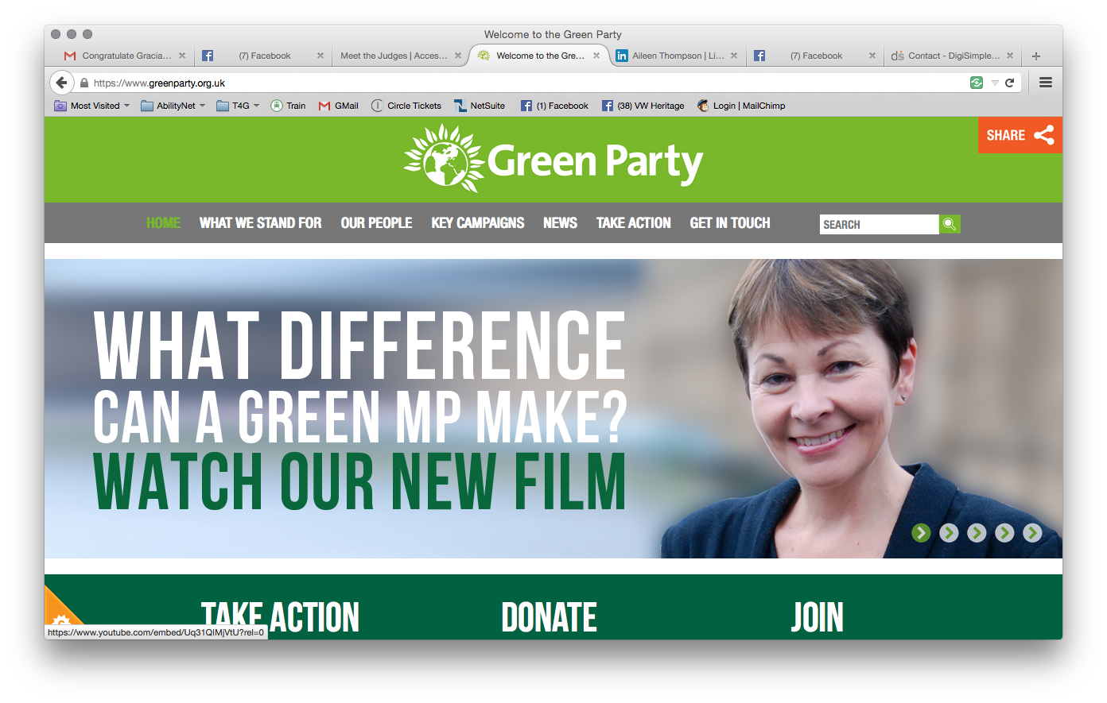

Technical compliance
- Amber

User testing
- Green

Accessibility help/info
- Red
- No accessibility or disability info links and no obvious site accessibility information to be found

User testing comments
Screen reader - Amber
"I could not immediately find any information about disabled people and no form to use to ask questions about their policies regarding disabled people. There was however an email to send enquiries to."
Magnification - Green
"All the text was bold and clear. However I tried to download the manifesto as a PDF but for some reason my anti-virus said it was dangerous and wouldn't allow me to open it. I don't usually have this problem!"
Dyslexia - Amber
Keyboard only - Green
"So refreshing to find the manifesto in an easy to find, logical place, and immediately accessible to me as a keyboard only user."
Fine motor difficulties - Amber
"The site is quite text heavy and the menu options don’t seem intuitive to me. This led to some extra clicking and scrolling that I would have rather avoided."
BSL - Amber

Conservative Party
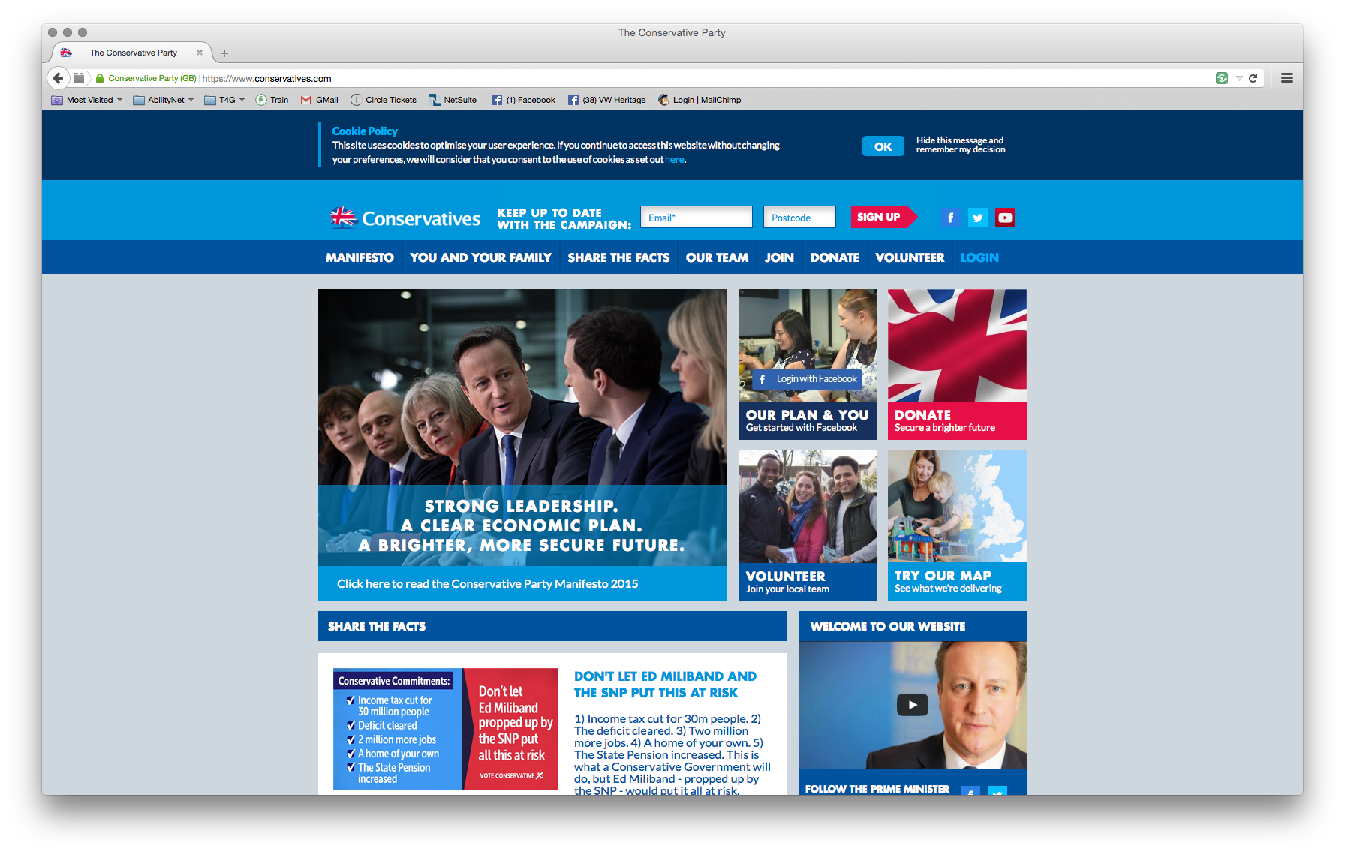

Technical compliance
- Amber

User testing
- Red/Amber but leaning towards Red

Accessibility help/info
- Red
- No accessibility or disability info links and no obvious site accessibility information to be found
User testing break-down:
Screen reader - Amber
"Lots of unlabelled images on this website. I couldn't see any information specifically about disability policies and so I found the form on the Contact Us page which was easy to fill in. Some specific info about disabled people would be nice, though."
Magnification - Green
"The website is very clear and easy to access. The colour contrast was good making it easy for me to read."
Dyslexia - Amber
"There was no option to search and no sitemap so didn't find it as easy to find what I was looking for as on the other sites."
Keyboard only - Red
"I was able to see the active links as I tabbed around using the keyboard – but only just, as they were blue, just like most of the website. In the footer I couldn't see them at all. Lost my vote - sorry!"
Fine motor difficulties - Red
"This website was the worst of the lot. It seemed to be organised to meet what the party wanted to tell us rather than what people might want to find out. I found it really frustrating to use and would have given up much quicker in real life. As someone who has to limit the amount of web browsing I do because of pain / motor issues, I feel annoyed that I wasted my time trying to find information. At the very least this page needs a search facility."
BSL - Amber
"I find the bold text and block capitals rather harsh to read and not very friendly. No BSL alternative is offered for any content although I appreciated that supplying a phone number is optional and not mandatory when contacting them as having hearing loss I don't want to be called."

UKIP
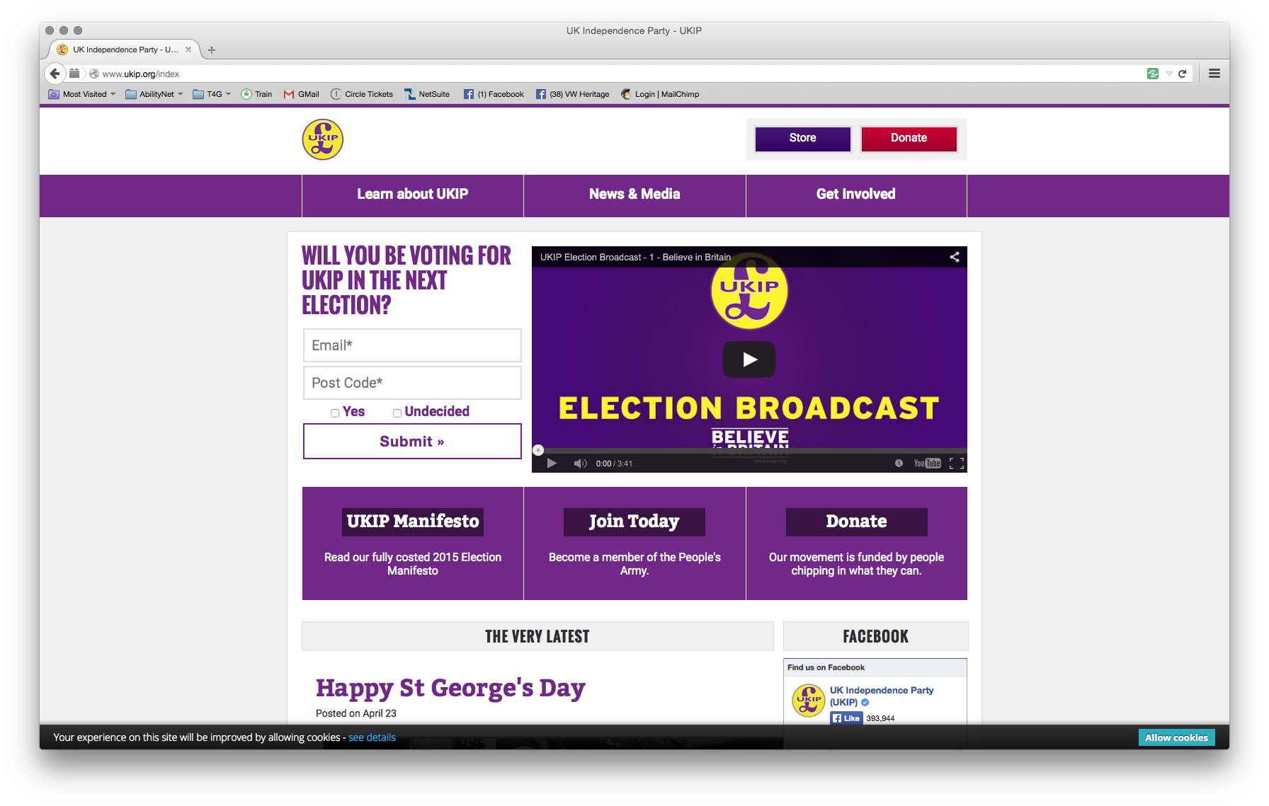

Technical compliance
- Amber

User testing
- Red

Accessibility help/info
- Red
- No accessibility or disability info links and no obvious site accessibility information to be found

User testing comments
Screen reader - Red
"Lots of unlabelled images on this site and I didn't find any information about disabled people or a place to send in a question about their policies for the disabled."
Magnification - Red
"I couldn't find any information about their disability policies and couldn't even find a search button. I also failed to be able to locate a form to send them an enquiry about it."
Dyslexia - Amber
"For people with dyslexia their Manifesto contains too much text, might be worth breaking the text into separate pages, making subheading larger and, using a different text colour."
Keyboard only - Red
"Using my keyboard I tried to tab through the main page content but I got trapped within the infinite Twitter feed – it just kept scrolling through previous UKIP tweets and I could do nothing more. A real vote loser."
Fine motor difficulties - Red
"I don’t appreciate having to close boxes to avoid answering whether I intend to vote for the party. Every extra mouse-click is irritating for me. This website is really frustrating. It’s difficult to navigate and the lack of obvious ‘search’ function makes it inaccessible to people with fine motor skill problems who are trying to minimise their computer usage."
BSL - Red
"There is no obvious way to search for what you want and no BSL version of the manifesto."

Party of Wales
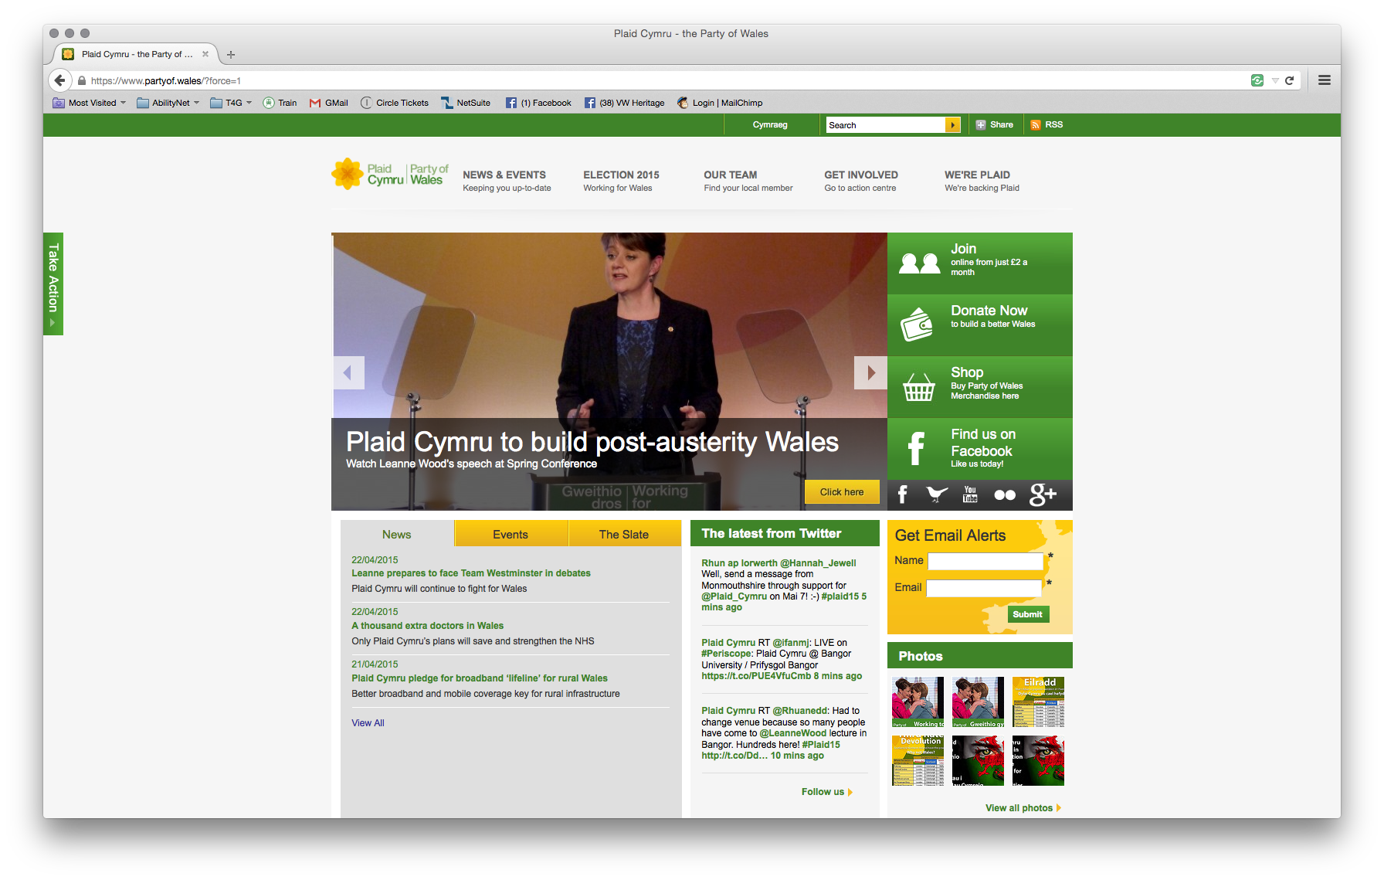

Technical compliance
- Red

User testing
- Amber

Accessibility help/info
- Red
- No accessibility or disability info links and no obvious site accessibility information to be found

User testing comments:
Screen reader - Amber
"I didn't find any information about disabled people but did find contact details and a form to send in general enquiries."
Magnification - Amber
"I found it easy to find the manifesto but the colour contrast on some pages (yellow on white) made it difficult to read for my magnification software and probably for everyone else too."
Dyslexia - Green
"They have an audio version of the manifesto available too which is very helpful if you have dyslexia."
Keyboard only - Red
"Using my keyboard I was not able to accept the message about cookies and couldn't see where I was as I tabbed through links on the page so I couldn't use this site at all - complete showstopper."
Fine motor difficulties - Amber
"At last - a party website that was incredibly easy to navigate. Gives me faith in the organisation. However if there is the facility to ask questions about policy then it is extremely well buried!"
BSL - Amber
"The Online viewer tool to read the manifesto is accessible in its basic format (full screen mode), though zooming into text is rather cumbersome and awkward. I would prefer zooming to be easier as some of the text is a little small. In addition, there is no BSL translation available."

Contact Us
Please contact us to find out more about this report, further information about the tests we conducted or any other aspect of AbilityNet’s work:
Tel: 01926 312847
Email: sales@abilitynet.org.uk
Web: www.abilitynet.org.uk/enation
AbilityNet, Microsoft Campus
Thames Valley Business Park, Reading, Berkshire RG61WG

AbilityNet is a company limited by guarantee in England and Wales No: 3469653. AbilityNet is a Charity, registered in England and Wales, registration number 1067673, and in Scotland registration number SC039866.

